***INDEX***

|  |  |  |
| --- | --- | --- |
| ***S.NO*** | ***TOPIC*** | ***PAGE.***  ***NO*** |
| *1.* | *INTRODUCTION*  *OVERVIEW*  *PURPOSE* | *2*  *2* |
| *2.* | *PROBLEM DEFINING AND DESIGN THINKING*  *EMPATHY*  *IDEATION AND BRAINSTROMING MAP* | *3*  *3* |
| *3.* | *RESULT* | *5* |
| *4.* | *ADVANTAGE*  *DISADVANTAGE* | *5*  *6* |
| *5* | *APPLICATION* | *8* |
| *6.* | *CONCLUSION* | *9* |

***1.INTRODUCTION:***

***1.1 OVERVIEW:***

* *In the realm of business and branding, creating a unique and impactful brand identity is the cornerstone of success. This comprehensive guide explores the process of crafting a brand name, establishing a branded email address, and designing a brand logo, all within the versatile framework of Canva.*
* *Once the brand's essence is defined, the journey unfolds with the creation of a brand name, a pivotal element that encapsulates your brand's character and resonates with your**target audience.*

***1.2PURPOSE:***

* ***Solving a Problem:*** *Many projects are initiated to address a specific problem or challenge. The purpose is to find a solution that mitigates or resolves the issue at hand.*

**2.PROBLEM DEFINITION AND DESIGNING THINKING:**

**2.1 EMPATHY MAP:**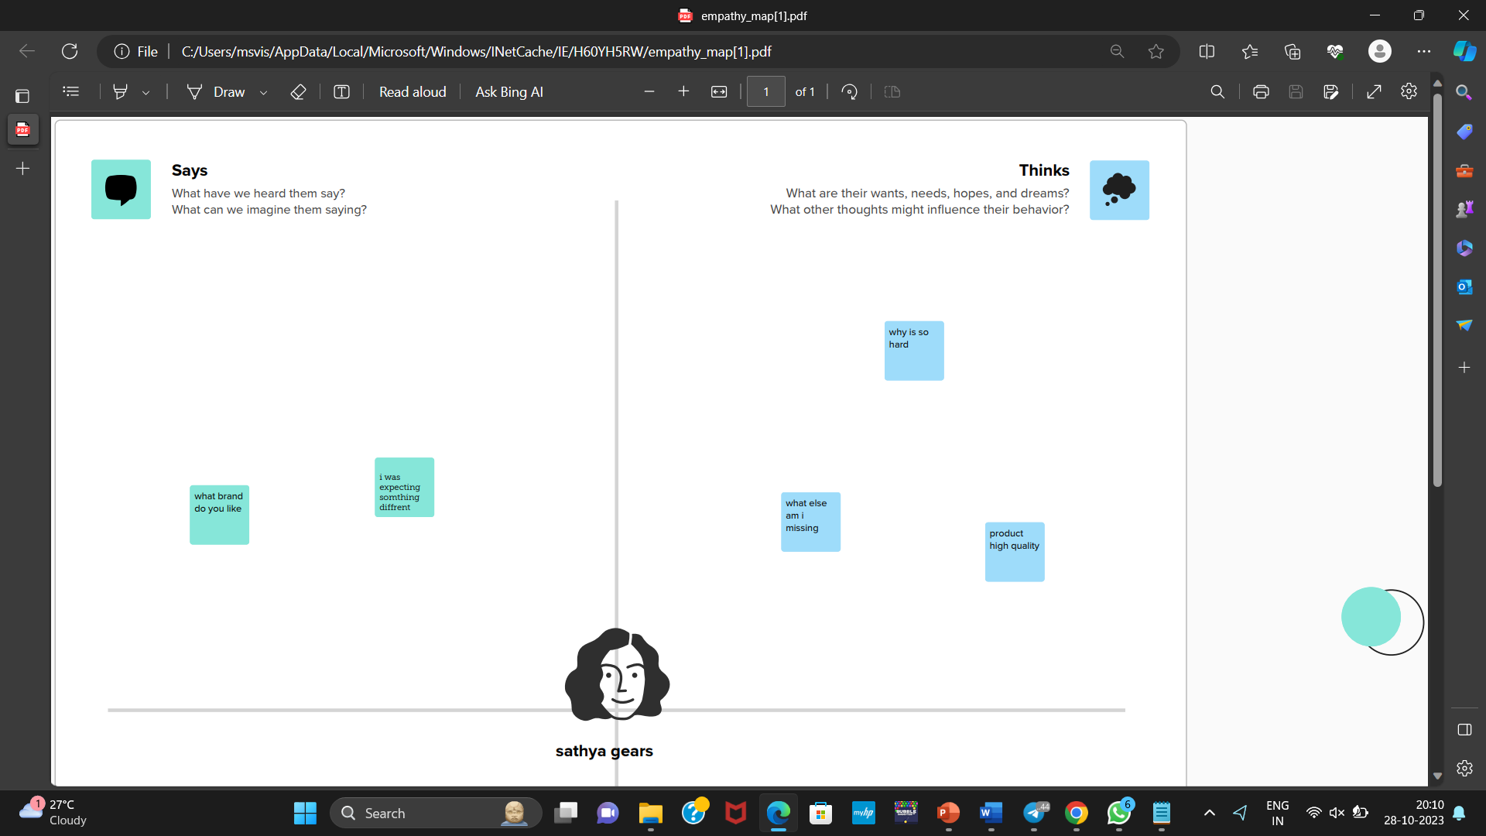

**2.2 IDEATION AND BRAINSTORMING MAP:**

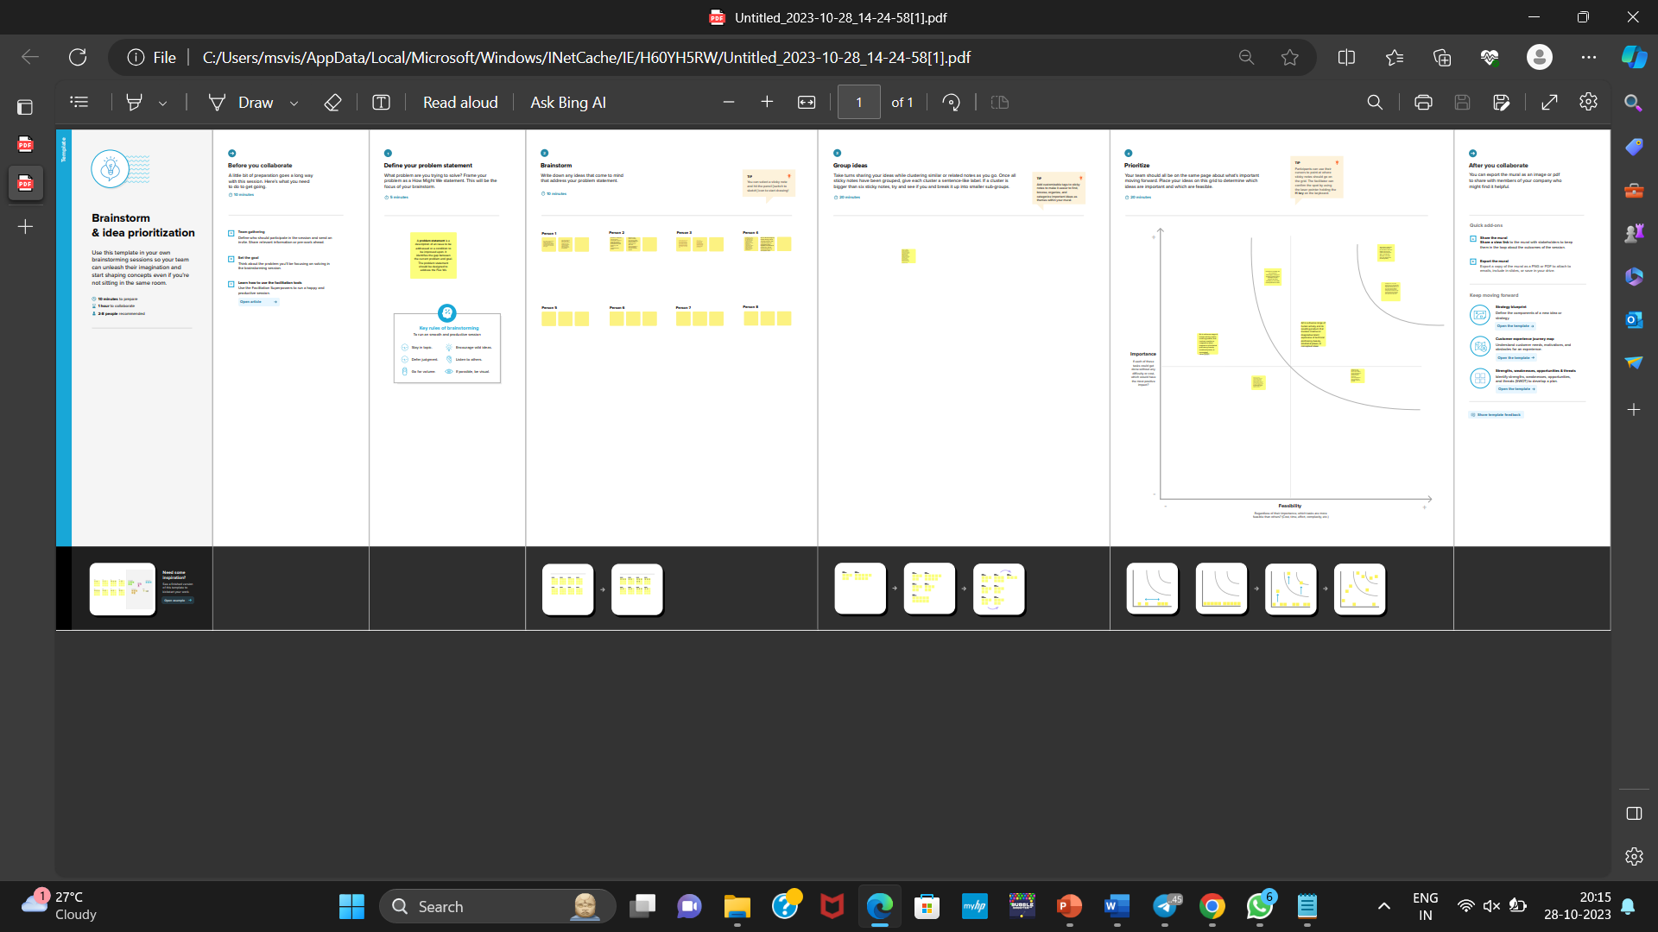

**RESULT:**



**ADVANTAGE:**

1. **User-Friendly and Accessible:** The solution offers a user-friendly platform, making it accessible to a wide range of users, including those with little to no design or technical experience.
2. **Cost-Effective:** By using Canva and offering educational content, the solution can significantly reduce the cost associated with branding compared to hiring professional designers.
3. **Time-Efficient:** Users can expedite the brand creation process as they have access to tools and guides in one place, eliminating the need to search for resources independently.
4. **Customization:** The solution provides customization options for brand names, logos, and email setup, allowing users to tailor their brand identity to their specific needs.
5. **Educational Resources**: Users benefit from educational content and tutorials, enabling them to understand branding principles and best practices.

***DISADVANTAGE:***

1. ***Limited Design Flexibility****: While Canva is user-friendly, it may have design limitations, which could restrict the creativity of advanced users.*
2. ***Overreliance on Templates:*** *Users may rely heavily on templates, leading to a risk of brand logos and identities looking generic if not customized sufficiently.*
3. ***Trademark Issues:*** *Users may not fully understand trademark laws, potentially leading to infringement issues if they inadvertently use a name or logo that's too similar to an existing brand.*
4. ***Lack of Personalized Design****: The solution may not cater to users with very specific and unique branding requirements that go beyond what Canva's templates offer.*
5. ***Technical Challenges****: Some users might still face technical hurdles when setting up branded email addresses or domain configurations, even with guides provided****.***

***APPLICATIONS***:

* Creating an application for the project of helping individuals and businesses develop their brand identity, including generating brand names, setting up branded email addresses, and designing brand logos in Canva, can provide a user-friendly and efficient solution

***Brand Name Generator:*** *Sathya gear engineering*

* *Users can enter keywords, values, and target audience information to generate brand name suggestions.*
* *Availability checker for domain names and social media handles.*
* *Option to save and shortlist favorite name ideas.*
* *Step-by-step guides and video tutorials on setting up branded email addresses.*
* *Recommendations for email hosting providers and domain registration services.*
* *Troubleshooting and support for email setup issues.*
* *Logo Designer with Canva Integration:*
* *Direct integration with Canva for logo creation.*
* *Logo templates with customization options for colors, fonts, and icons.*
* *Real-time preview of logo on different branding materials (e.g., business cards, websites).*

***CONCLUSION:***

* *The development of an application that assists individuals and businesses in creating a cohesive brand identity, comprising brand names, branded email addresses, and brand logos, represents a valuable solution in the realm of branding and design. By considering the unique features and advantages of the application, as well as addressing potential challenges and limitations, we can conclude that such an application can offer significant benefits to users and the business.*